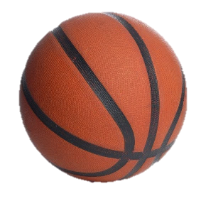
MONTICELLO GIRLS BASKETBALL
2021-2022 SCHEDULE
8th Grade All games are at 3:30pm
Coach: Billy Arn (barn@longview.k12.wa.us)
DATE | OPPONENT(S) | LOCATION
Nov. 10 Wed. | vs Mt. Solo 8th | Mt. Solo
Nov. 15 Mon. | vs Monticello 7th | Monticello
Nov. 17 Wed. | vs Cascade | Monticello
Nov. 29 Mon. | vs Monticello 7th | Monticello
Dec. 1 Wed. | vs Mt. Solo 8th | Monticello
*Dec. 6 Mon.  ************** | vs Kalama Middle/High  Entry Fee: $3 Adults $2 Children | Kalama  Return Bus Provided
Dec. 8 Wed. | vs Monticello 7th | Monticello
Dec. 13 Mon. | vs Cascade | Cascade
Dec. 15 Wed. | vs Monticello 7th | Monticello
*Bus will bring us home from the 12/6 Kalama game: Return time approx. 5:00 p.m.
7th Grade All games are at 3:30pm
Coach: Jamal Parlin (jamalparlin@gmail.com)
DATE | OPPONENT(S) | LOCATION
Nov. 15 Mon. | vs Monticello 8th | Monticello
Nov. 17 Wed. | vs Mt. Solo | Mt. Solo
Nov. 29 Mon. | vs Monticello 8th | Monticello
Dec. 1 Wed. | vs Mt. Solo 7th | Mt. Solo
Dec. 6 Mon. | vs Cascade | Monticello
Dec. 8 Wed. | vs Monticello 8th | Monticello
Dec. 15 Wed. | vs Monticello 8th | Monticello
*No return buses for away games (Except 12/6 8th grade only from Kalama)

Pictures Dec. 2nd at 2:45 in gym.

Awards Ceremony Wednesday Dec. 15th @ 4:30ish (after last game) in café. See coach for more details.

Family members of Athletes (siblings with an Adult) are allowed at all games home & away
All spectators must wear masks and sit 3 feet away from others
*****No charge for game entry- Except Kalama Game on 12/6 -No food or Drink in the gym-

Athletic Director: Gina Ramsey (gramsey@longview.k12.wa.us) 360-575-7041

